After collecting data, the dataset has been cleaned and converted from text to numerical values. We do no deducted any features because every feature contains valuable information to make students' decisions. Next, before splitting the dataset has been shuffled 150 times. The dataset has been divided into two parts 70% for testing and 30% for training.
We apply SVM to our dataset by using sklearns (scikit-learn) that is a python predictive data analysis library. Since our dataset is linearly separable (easily can separate by drawing a line), that is why we have used linear kernel (kernel='linear'). Since we did not collect a sufficient amount of data due to covit-19 pandemic, to overcome overfit and to minimize error we have used bias-variance value 10 (we denoted as C). we have gotten 239 support vectors, and by using 239 support vectors our model has been drawn its decision boundary to classify satisfied and dissatisfied class. By using our model, we have tried to maximize margin so that our model can easily classify new unknown data.
Similarly, by using sklearns, a python predictive data analysis library, we apply RF to our dataset. Among three algorithms (Brute Force, K-D Tree, and Ball Tree) we have used K-D Tree (short for K-dimensional tree) in our model because KD tree is a binary structure tree that recursively partitions the parameters space along the data axes, and the construction of a KD three is comparatively faster than other two. By calculating the square root of our training dataset, we set our n_neighbors’ value as 15. The model has been used its default leaf size that is 30.
From our given dataset the RF model has been constructed 60 equivalent decision trees. Based on the answer to the question each node has been split and based on a value of a feature the question has been asked. Since the leaf node our target node, so no question is asked to any leaf node. Among 20 trees, we have given a tree as an example [].

Result and Observation
The confusion matrix has been represented after fitting the training data into SVM, KNN, RF, and ANN model, and by using training data predicted through the models. A table is given below [] which contains True Positive (TP), False Positive (FP), False Negative (FN), and True Negative (TN) values from the test data.

Method | Precision | Sensitivity | Specificity | Accuracy
SVM | 94% | 100% | 97% | 99%
KNN | 31% | 100% | 73% | 89%
RF | 62% | 100% | 82% | 94%
ANN | 92% | 80% | 78% | 79%
The scikit-learn library has been used, to evaluate SVM, KNN, and RF model’s evaluation metrics, and to evaluate ANN the TensorFlow has been used. All models have acquired pithy results according to accuracy, precision, sensitivity, and specificity. According to table [], SVM achieved high result 99% among all, ANN produced second high 97%, and KNN and RF acquired 89% and 94% successively.

- Satisfaction and dissatisfaction with teacher
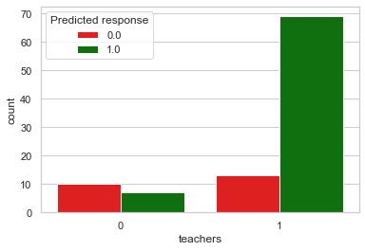
(b) Satisfaction and dissatisfaction with political issue

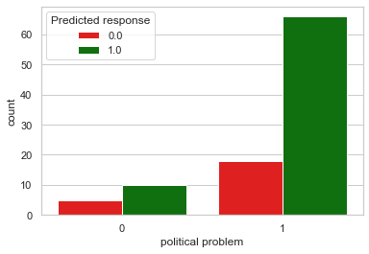

- Satisfaction and dissatisfaction with sexual harassment
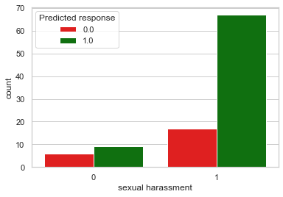
- Satisfaction and dissatisfaction with sexual harassment

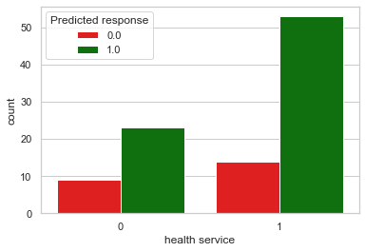

- Satisfaction and dissatisfaction with accommodation

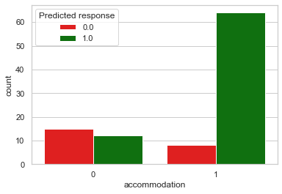
- Satisfaction and dissatisfaction with accommodation

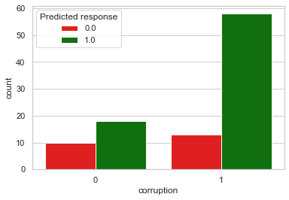
A python plotting library the matplotlib has been used to plot predicted values after applying the ANN model. To compare and to analyze the result attributes are taken in the x-axis. The y-axis exhibits the count of the value of that attribute. Figure [a] shows that some students satisfied with teachers’ behavior, and they are satisfied the overall education system. Another observation is that some students do to satisfied with teachers’ behavior, but they are satisfied on overall education system. So, if any student satisfied with teacher behavior, the probability of satisfied on overall education system is high. According to figure [b], some student satisfied with political issue, and they are satisfied on overall education system. Nevertheless, there are few numbers of student who dissatisfied with political issue and satisfied on overall system. So, it can be noticed that political instability effects on students to make the decision. Figure [c], demonstrate that maximum students satisfied who does not face sexual harassment. Figure [d], reveals that if host country provides a good health service, the huge number of students have positive intention with overall education system. figure [e], illustrate that if host country gives a good environment to study and accommodation, then the students satisfied with overall education system. figure [f], shows that corruption is one of the major factors to make a student decision.

Future Research Directions and Conclusion
In this study we have collected data from current foreign students and analyze what kind of problems they are facing and how to solve these problems. are they satisfied or dissatisfied with the Bangladesh educational curriculum? we have collected data from foreign students studying is Bangladesh. five popular classification algorithms have been used on the algorithm. According to the results support vector machine classifier works better among all the other classifiers for this dataset. in this paper, we have collected data from the students of only two countries (Somalia, Uganda) studying Bangladesh. in the future, we will collect a large amount of data form all countries students who studying in Bangladesh. and also, we will try to apply more classification algorithms for better results.

